R & D Challenges

1.Install Docker on AWS EC2
Step 1: launch EC2 instance
Step2: connect to instance
Step3: install docker by below command
Sudo yum install docker
Step4: start and check status of docker whether it is running or not
Sudo systemctl start docker
Sudo systemctl status docker
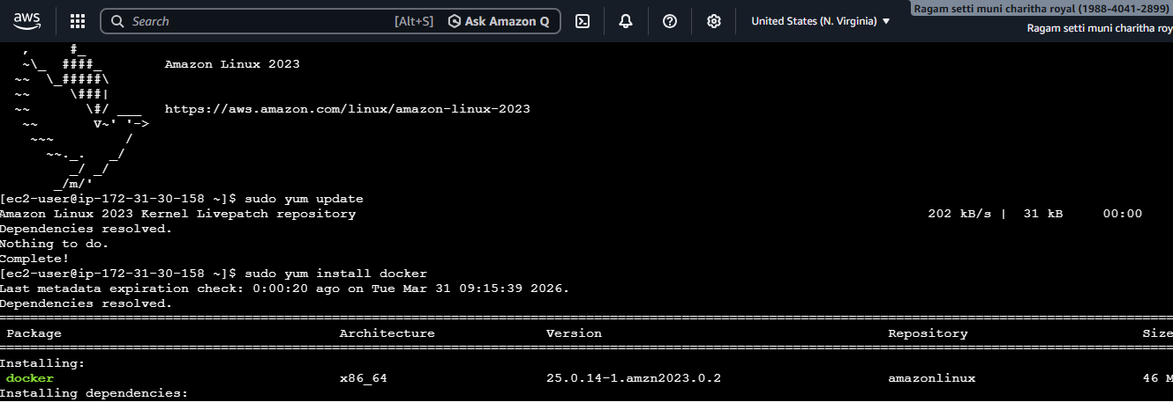
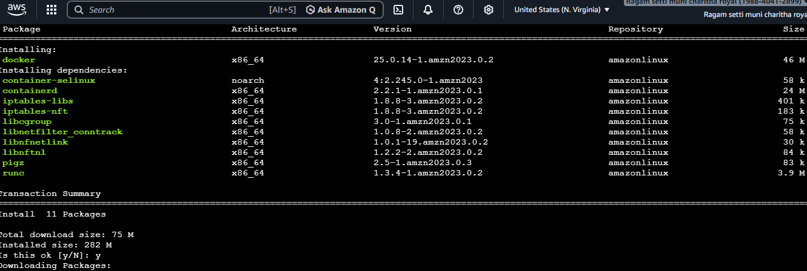
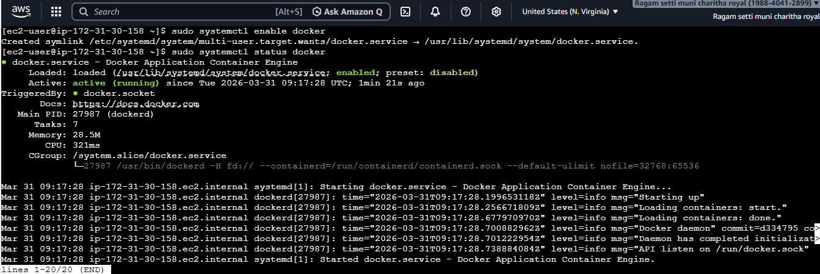
2.apache(httpd)
- Sudo yum install httpd – Install apche
- Sudo systemctl start httpd
- Sudo systemctl enable httpd
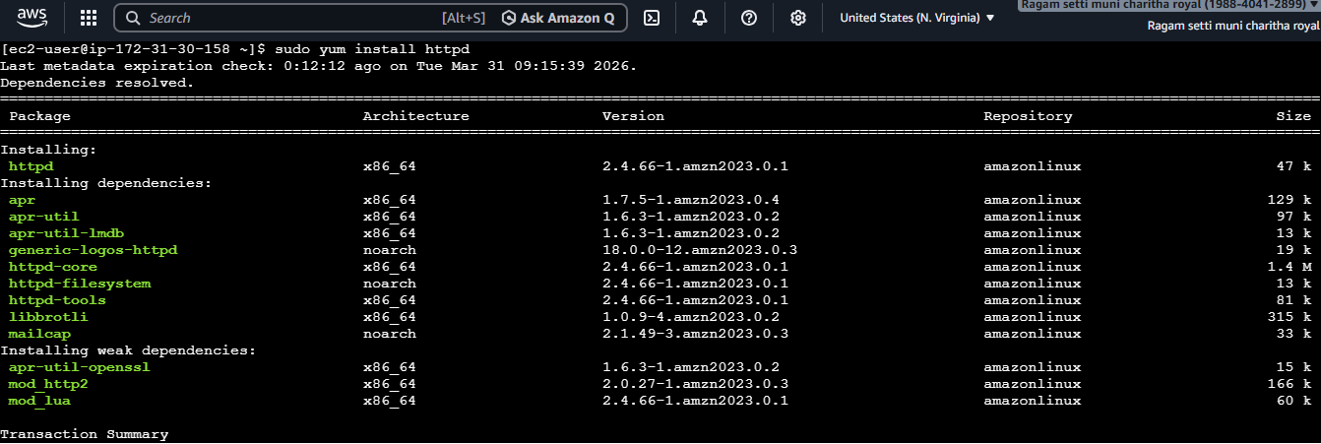
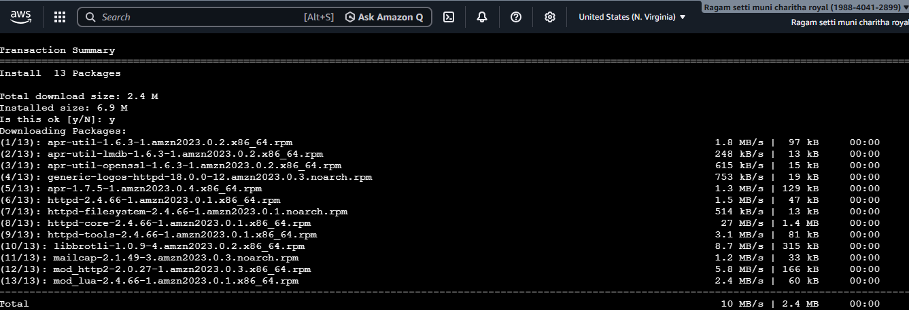
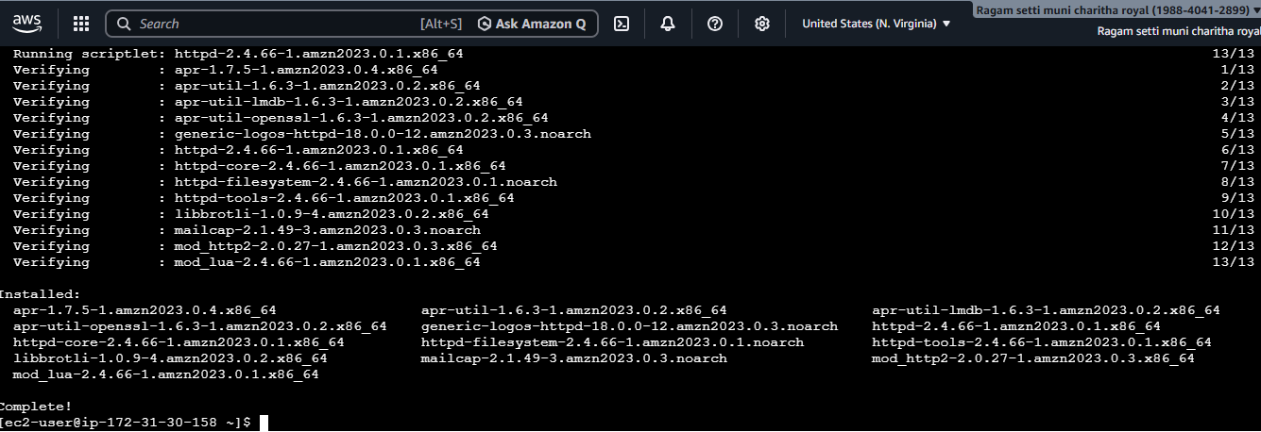
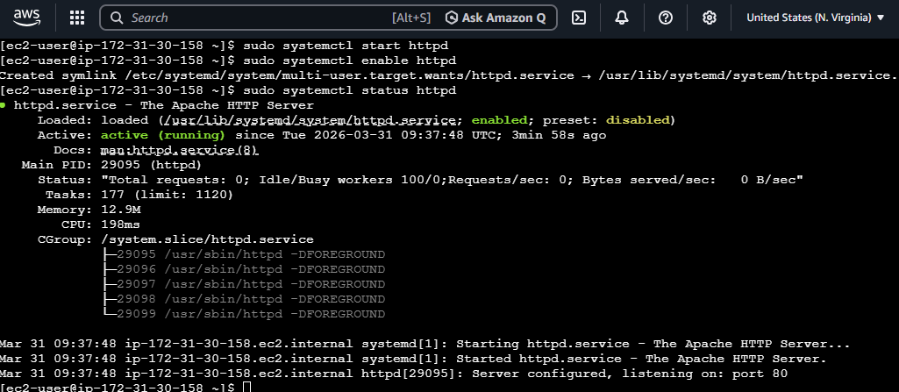

3.Jenkins
- First I have installed java
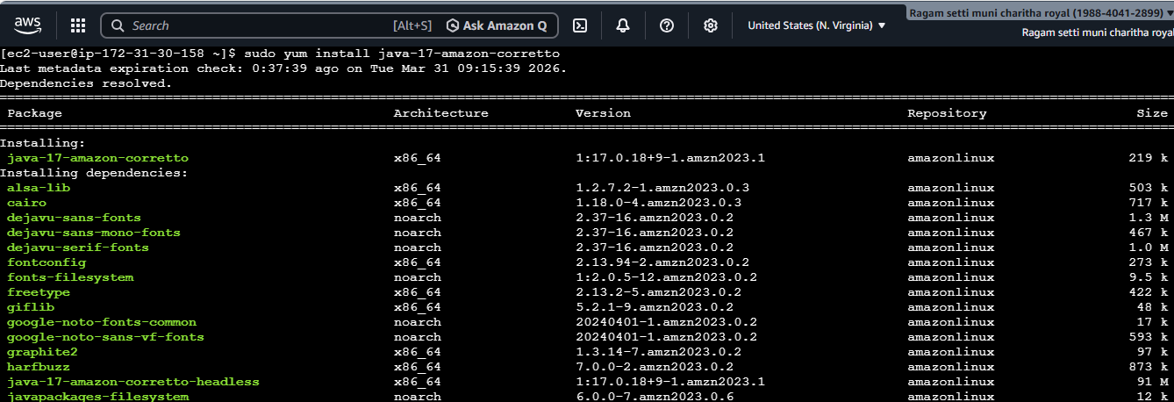
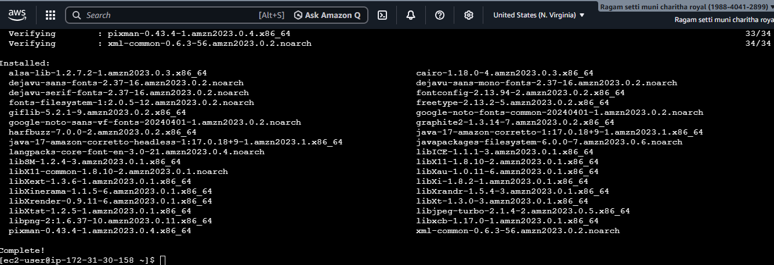
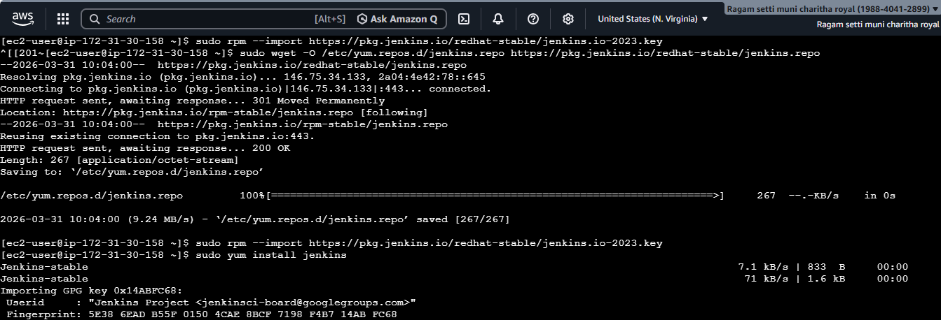
- Added Jenkins repositories
- Imported Jenkins key
- Installed Jenkins
- Configured security group, I have added port number 8080
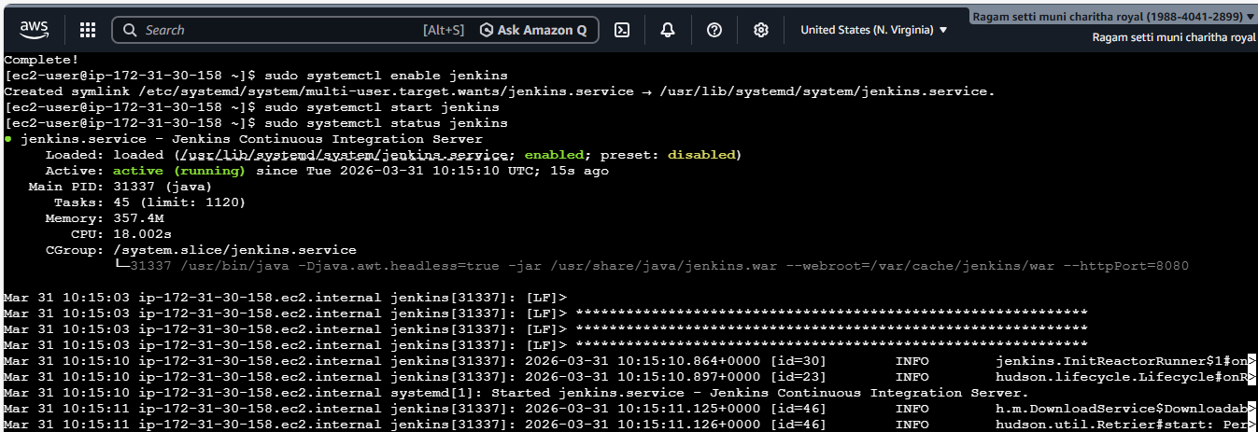
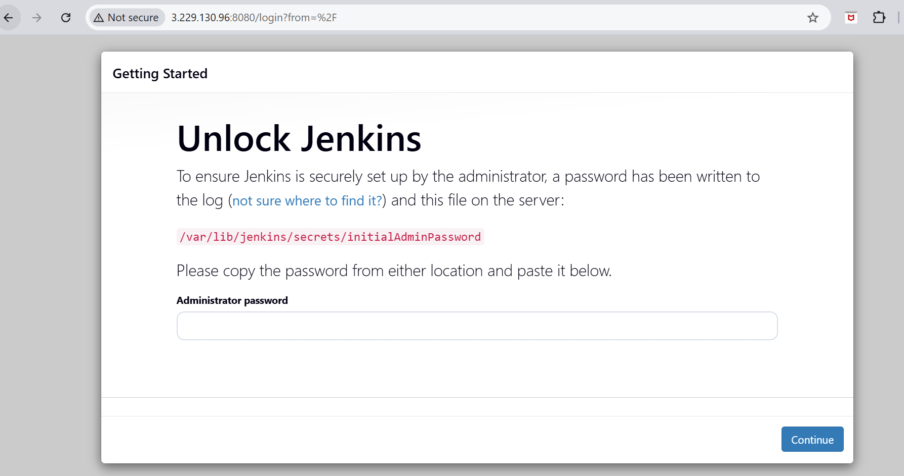
4.install nginx
- I have installed nginx
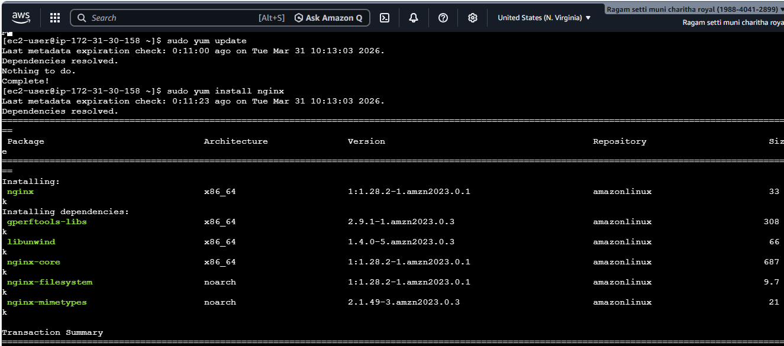
- Started nginx service
- I have checked the status whether it is active or running

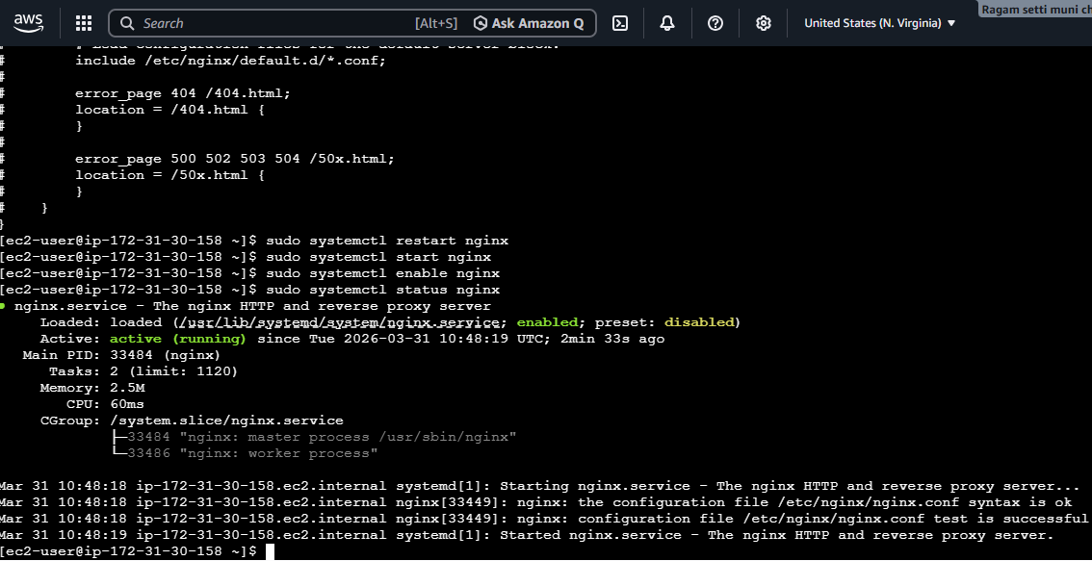
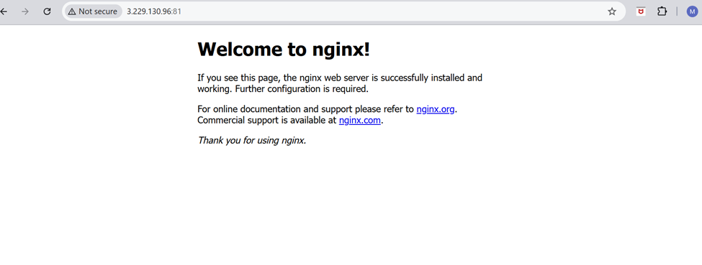
5.apache tomcat
- First I have downloaded the package from browser and installed by wget command
- I have extracted the downloaded tar file
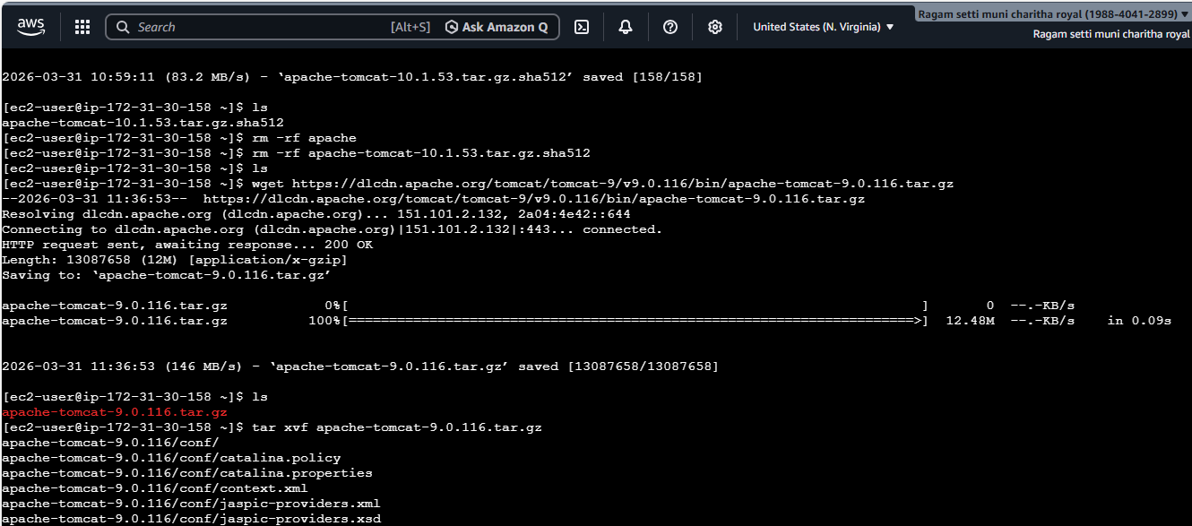
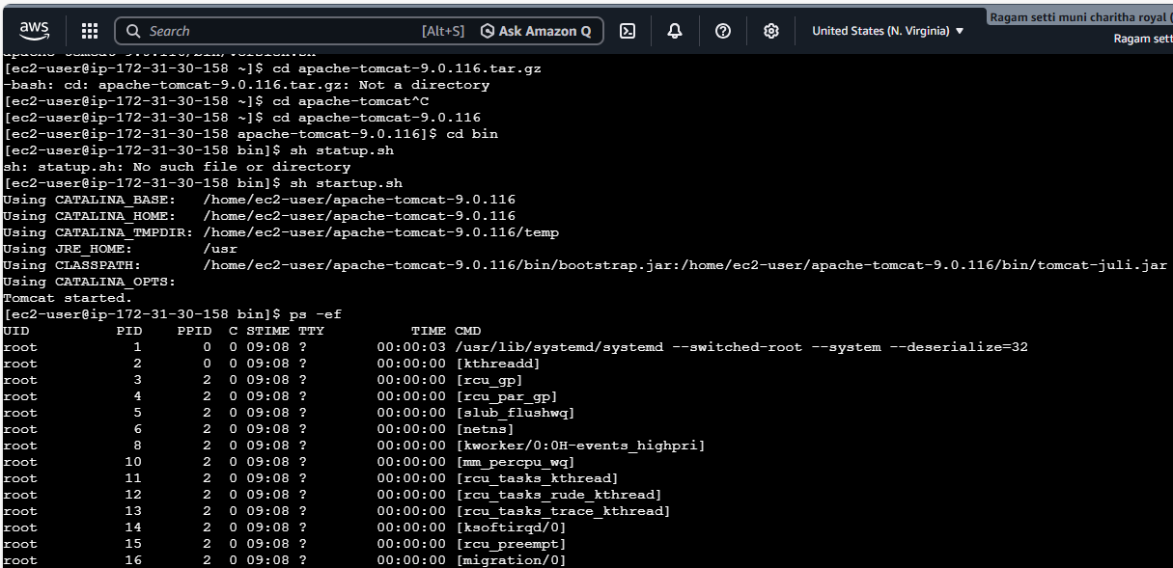
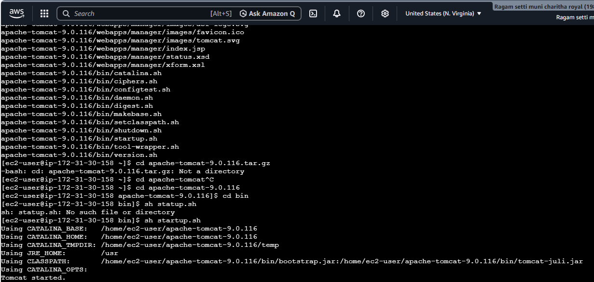
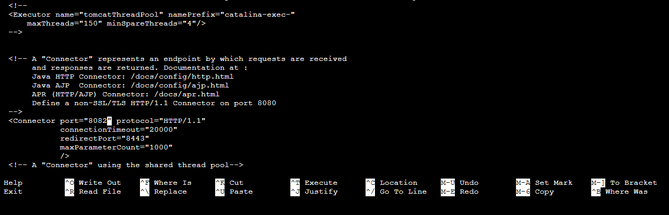
- I gave the port number as 8081
